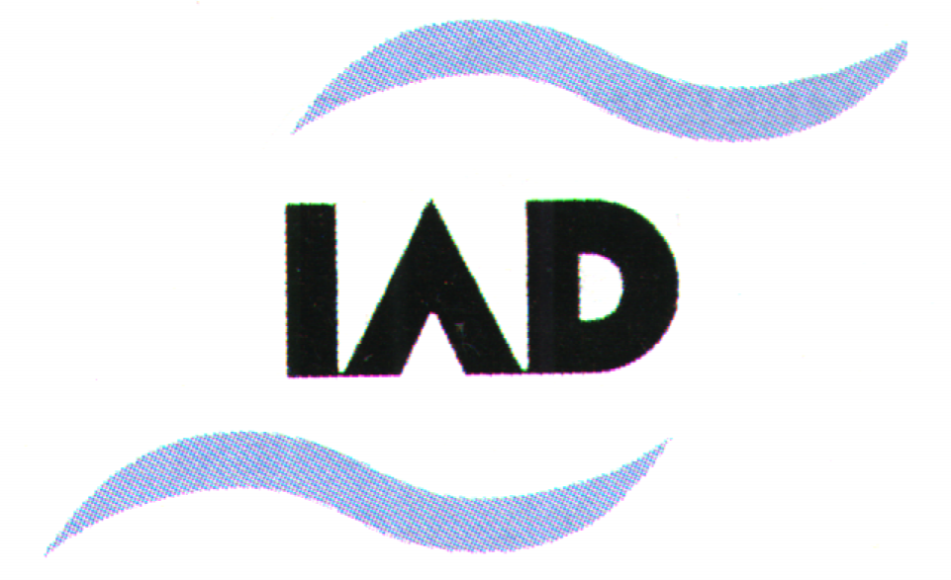
INTERNATIONAL ASSOCIATION OF DANUBE RESEARCH
in the Societas Internationalis Limnologiae

MACROINVERTEBRATE EXPERT GROUP

Co-ordinator Dr. Nándor Oertel
Hungarian Danube Research Station of Hungarian Academy of Sciences
H-2131 Göd, Jávorka S. u. 14., HUNGARY
Telephone:+36-27-336610, Telefax: +36-27-345023, e-mail: oer63@ella.hu

28. February 2005
Dear Colleagues,

With this particular Circular Letter I should like to keep you informed about some events of the previous period, which more or less closely related to the activity of the IAD Macroinvertebrate Expert Group. You can get more information on the IAD and SIL homepages (www.iad.gs, www.limnology.org).

At the beginning of 2004 a two-year German-Hungarian project was finished, which were initiated by Prof. Dr. Thomas Tittizer and Dr. Nándor Oertel in 2002, as practical co-operation within the IAD MEG. In the project “Macroinvertebrate investigations on the German and Hungarian Danube sections with particular reference to fundamental (biodiversity, migration, discontinuity) and practical (sampling methods, water quality assessment) questions” senior research fellows and PhD students took part from the institutions of the Zoological Institute of University Bonn, Bundesanstalt für Gewässerkunde and the Hungarian Danube Research Station of H.A.S. In the frame of this co-operation the participants exchanged experience on sampling methods usable in large rivers (Rhine and Danube), compared the efficiency of quantitative sampling techniques in the Hungarian Danube section, collected macroinvertebrates for the evaluation of biodiversity of the German section and the Szigetköz wetland area in Hungary. In the second year the project was widened with the investigation of neuromast of different fish species living in lotic and lenitic environments. In addition to the successful consultations and common practical work, the project afforded possibilities to contact people and laboratories personally and to draw PhD students into scientific work. The German Academic Exchange Service (DAAD) and the Hungarian Scholarship Board (MÖB) financially supported the project.

In April of 2004 IAD hold her 35th Conference in Novi Sad, which was organised by the National Committee of IAD Serbia and Montenegro, the Provincial Secretariat for Environmental Protection and Sustainable Development of Autonomous Province of Vojvodina and the University of Novi Sad. Five keynote speakers and more than 90 lecturers contributed with oral and/or poster presentations to the general topic “Scientific concepts and implementation of sustainable transboundary river basin management”. All contributions were divided into three major topics: 1. Wetland, Restoration, Modelling; 2. Water Quality Monitoring, Pollution, Nutrients; 3. Biodoversity. Within the two latter topics 5 oral lectures and 13 posters dealing with macroinvertebrates were listed in the program. It was a pity that some of them were not presented because of the absence of the authors and the Macroinvertebrate Expert Group meeting was attended by only three persons (Elitsa Petrova Petrova, Dr. Gunther Seitz, Dr. Nándor Oertel). At the same time, good news, that all the papers were published in the Conference Proceedings – Limnological Reports 35 – both in printed and CD version. If somebody is interested in the Proceeding volume, let me know, and I make a copy of the CD version.
In March 2004., in the Danube News (No. 9.) a paper briefly summarized the changes in the macroinvertebrate fauna of the Szigetköz wetland area (Hungary), which has began by the diversion of the Danube in 1992. Some of the main results are:
- The percentages of those species, which occur in only one water body, have decreased, while the taxa in common have increased.
- A comparison of the changes in the three areas of the Szigetköz (abandoned main arm, flood plain and protected area), shows the process of how they became uniform during the last decade. The previous spatial composition and distribution pattern of the aquatic macroinvertebrate fauna, which could be characterized by the topography and flood protection, is lost. The former barriers of the distribution practically disappeared because of the different water supply techniques; the macroinvertebrates can penetrate to the whole water system of the Szigetköz area.
- Comparing to the status of five years ago, one can state that, significant changes have became for 2003 in the distribution of 11, 12 and 6 taxonomic groups of the main arm, flood plain and protected area, respectively. In the last years many lenitic species (such as Lymnaea stagnalis) appeared in the Old-Danube, while lotic species (e.g. Ancylus fluviatilis) populated the water bodies of the protected area. That kind of “inner” migration among water areas is the cause of the increase in group and taxon number. The percentage of the real invasive species (such as Hypania invalida, Corbicula fluminea/fluminalis) is not significant.
Nosek. J.N., Oertel. N. (2004): Changes of the macroinvertebrate fauna in the Szigetköz. Danube News, No. 9:1-4.

During August, 8-14. 2004. the 29th SIL Congress was held in Lahti, Finland. The congress was dedicated to those ideas, which were formulated in the invitation of Prof. Timo Kairesalo, Chairman of the organization Committee:

“Sustainable and wise use of aquatic ecosystems and water resources has become a matter of widespread and intense concern leading to new international legislation in the spirit of the Rio Earth Conference. For instance, implementation of the European Water Framework Directive, a framework for Community action in the field of water policy, will require better understanding and evaluation of the ecological and biological quality of aquatic ecosystems as well a holistic, catchment approach to their management and rehabilitation. Unhealthy aquatic ecosystems, and seriously diminished and unequal availability of clean freshwater, call for high-quality limnological research and expertise to underpin the development of sustainable water policies and management actions worldwide.
Boat designs, such as the one in our logo, occur frequently in Finnish rock paintings dating from the Stone Age. Ancient Finno-Ugrians typically painted these designs at the water's edge, demonstrating the importance to their culture of lakes and watercourses. We are still in the same boat seeking new innovations and common experiences.”

In the session of “Macroinvertebrates and benthic communities” 33 oral presentations and 23 poster presentations demonstrated the most recent results of macroinvertebrate research both in the field of theory and practice (e.g. European Water Framework Directive). I am sorry, but I guess, our presentation was the only oral lecture, which represented the IAD/MEG. (Oertel, N., Nosek, J.N.: Sampling macroinvertebrates by artificial substrates in the River Danube.)
To have more general information, see the presidential report of Jürg Bloesch in the Danube News No. 10. (2004, November).
In my latest Circular Letter I launched an idea to build a complete and up-to-date species level database of the aquatic macroinvertebrates living in the River Danube. Former lists (such as the one in the volume of “Limnologie der Donau”) must be revised and updated to construct a solid reference of the given time. Steps was planned such as:
- Collecting all published data of the River Danube and her confluents.
- Completing the former dataset according to the data of current studies, which already reflect all the effects (migration, invasion, neozoa, etc.) that were caused by the latest human activities (regulation, canalisation, damming, impounding, fragmentation, etc.).
- Creating and publishing the reference macroivertebrate database of the Danube catchment’s area in printed and/or electronic (web site, CD, etc.) form.
Not to much reflections came back, to tell the true, not one. I am convinced, that kind of database should be the reference both in space and time for any kind of fundamental research and water management (research of the pathways of matter, biomonitoring, saprobiological water quality assessment, water quality mapping, etc.). As I do believe only such a kind of a recent and coherent species list can form strong base for the successful implementation of the EU Water Framework Directive along the whole length of the Danube. Henceforward I should like to encourage everybody to express her or his opinion about this concept and add further remarks, ideas to it.

Further ideas or proposals concerning group work within the frame of IAD are very welcome.

Some futher general information on IAD matters:
- Ivana Teodorovic was elected as new president of the IAD from 2005,
- 36th IAD Conference (50 years’s Jubilee) is planned for 2006 in Austria,
- and more on IAD homepage (www.iad.gs).

Wishing success in your professional and private life for the year 2005.

Yours sincerely,

Dr. Nándor Oertel
Co-ordinator of IAD/MEG

